1. mvn clean install

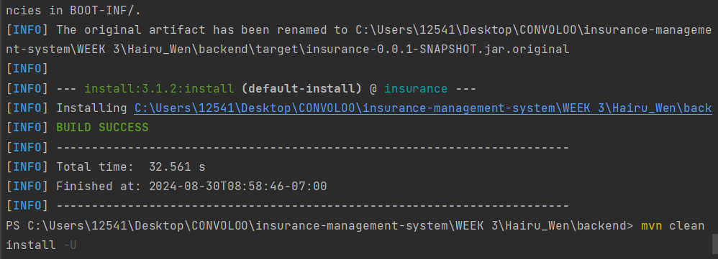

1. mvn spring-boot:run

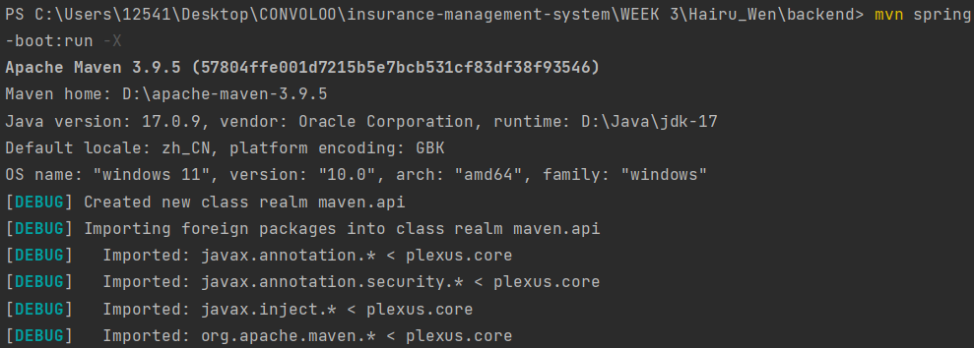

SUCCESS (no err):

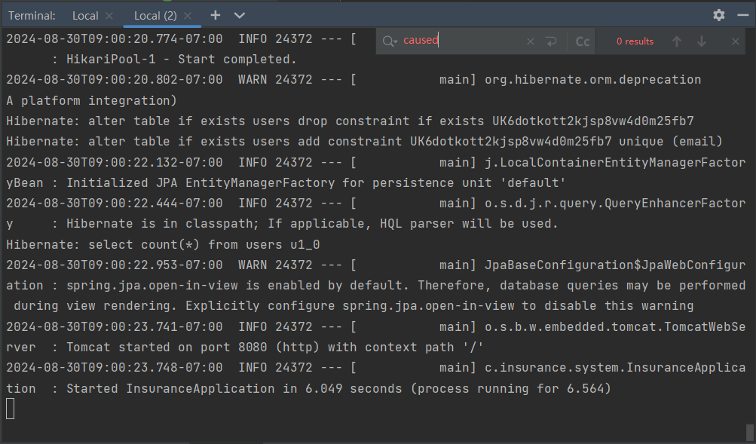

After successfully running the backend, I don’t know where to insert the ‘MotorPolicy’ thing to it, so I just started with testing Controllers.

1. TESTING ‘UserController’:

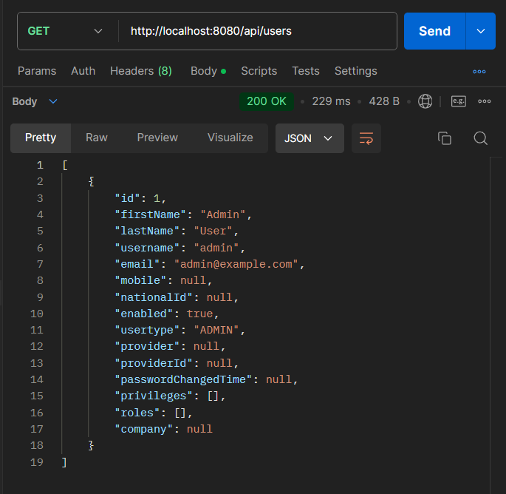

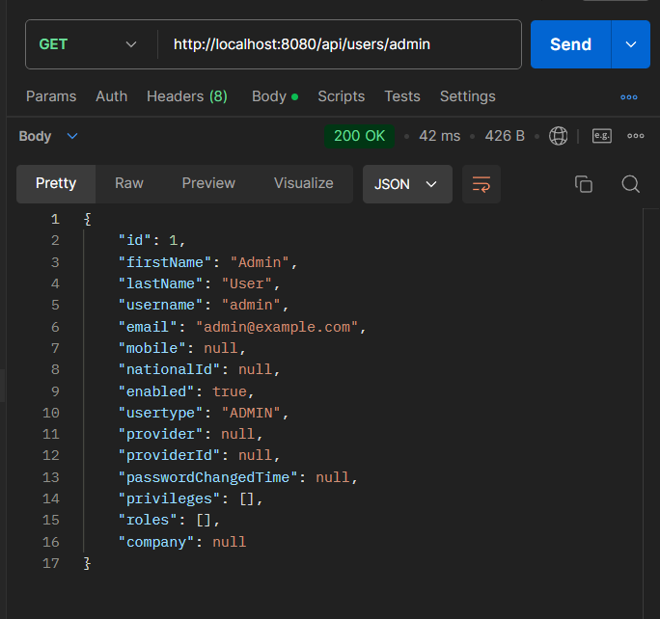

1. TESTING ‘RestPolicesController’:

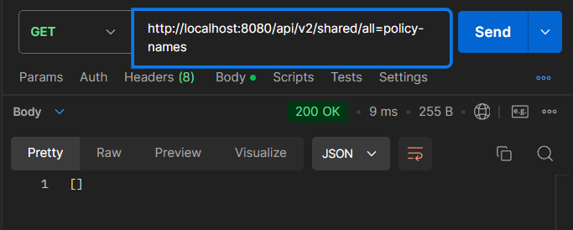

But then I was confused, since in the tasks it said the project is already tested. So I just need to add my thing to this project and run it, right?

I see ‘InsurerRepository’ already exists, but no ‘InsurerController’, so how should I add my code to the project that you sent me to make sure the needed ones are added without repeating?

1. Run the frrontend’:

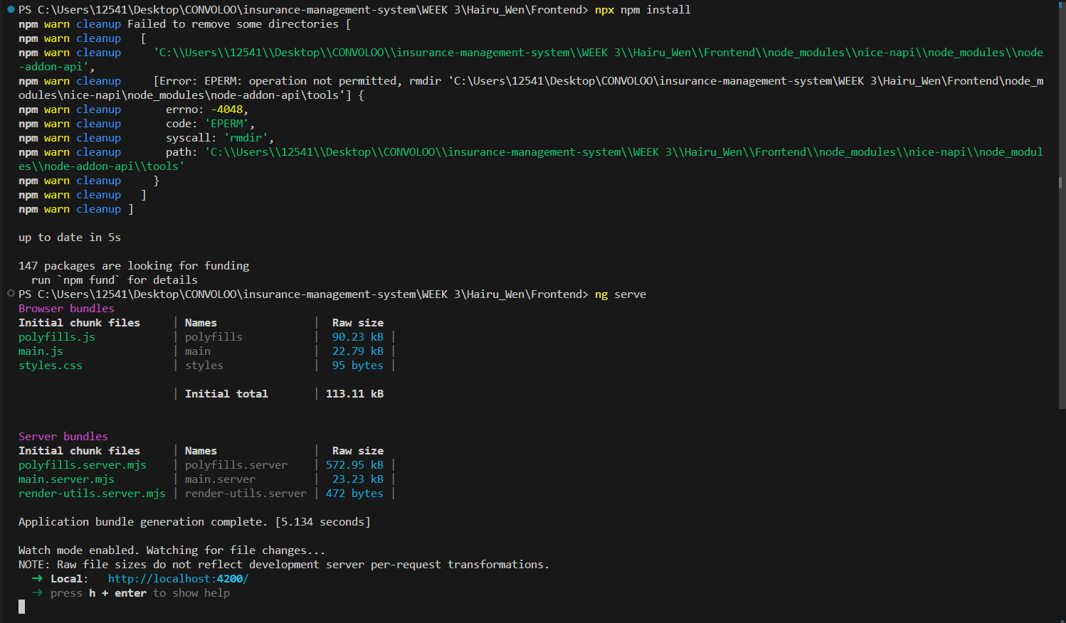

In ‘http://localhost:4200/’

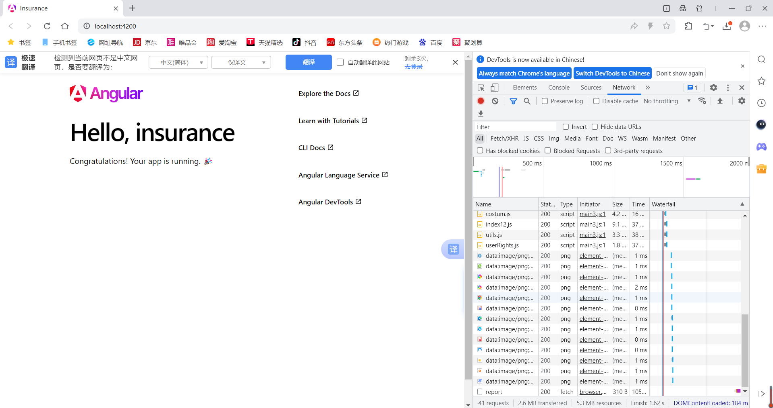

Seems nothing there.

1. For the frontend I created last week, it always has this err

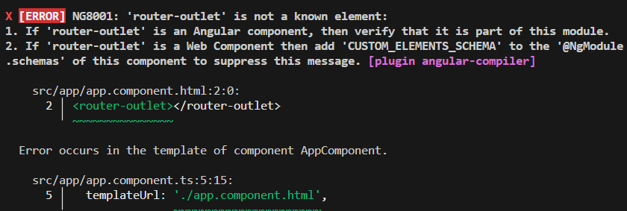

And I really don’t know what to do with it. I checked ‘app.module.ts’, ‘app.component.ts’ and ‘app-routing.module.ts’ but didn’t find anything wrong.